**Performed by:**

**Saurabh Jadhav : 192010045**

**Trupti Tekawade : 192011063**

**Shriram Bhagwatkar : 192010051**

Experiment No.8:Implementation and Validations.

USER INTERFACE SCREENSHOTS

Home Screen

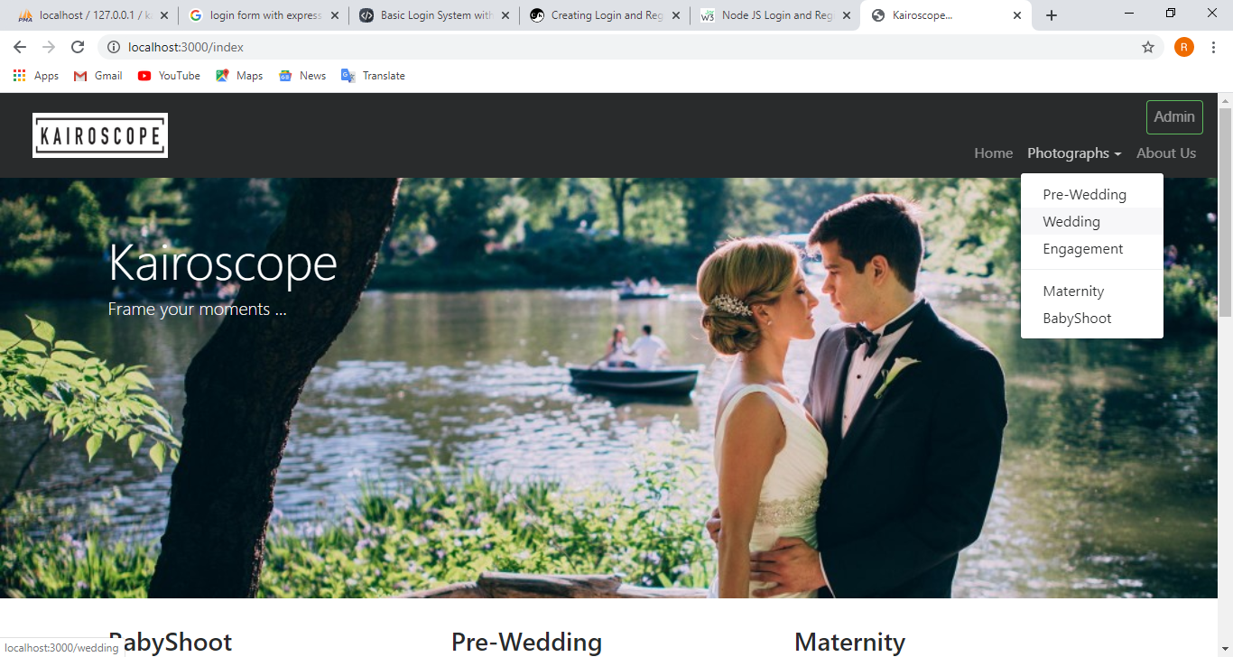

About Us

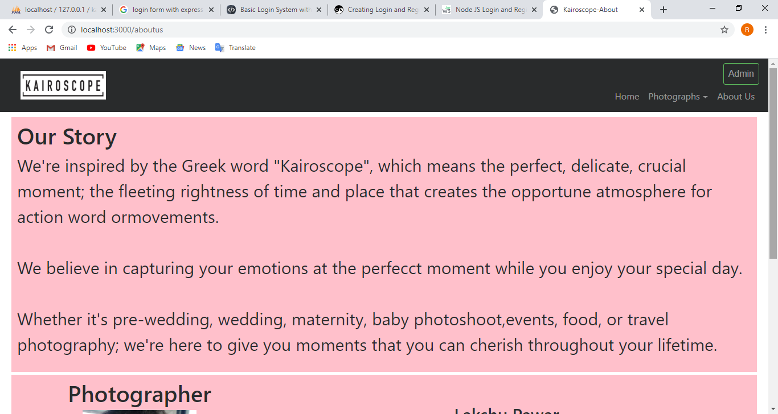

Admin Login Page

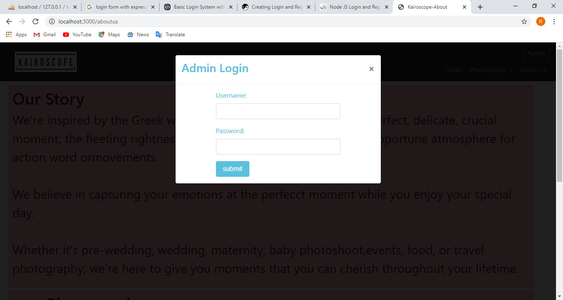

Admin Panel

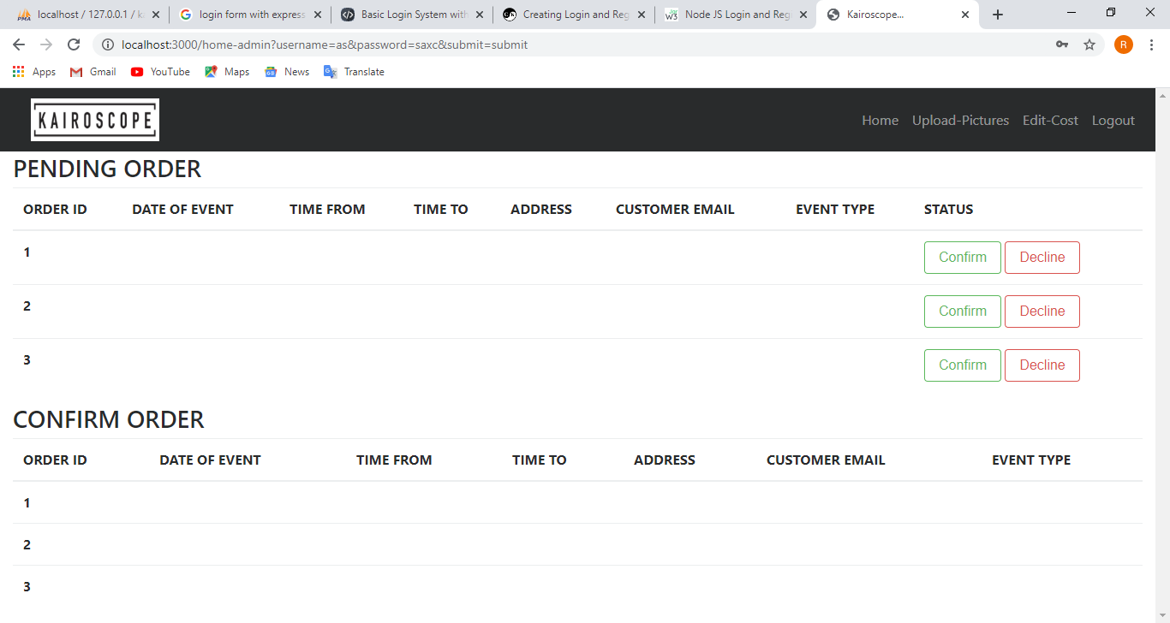

Upload Photos

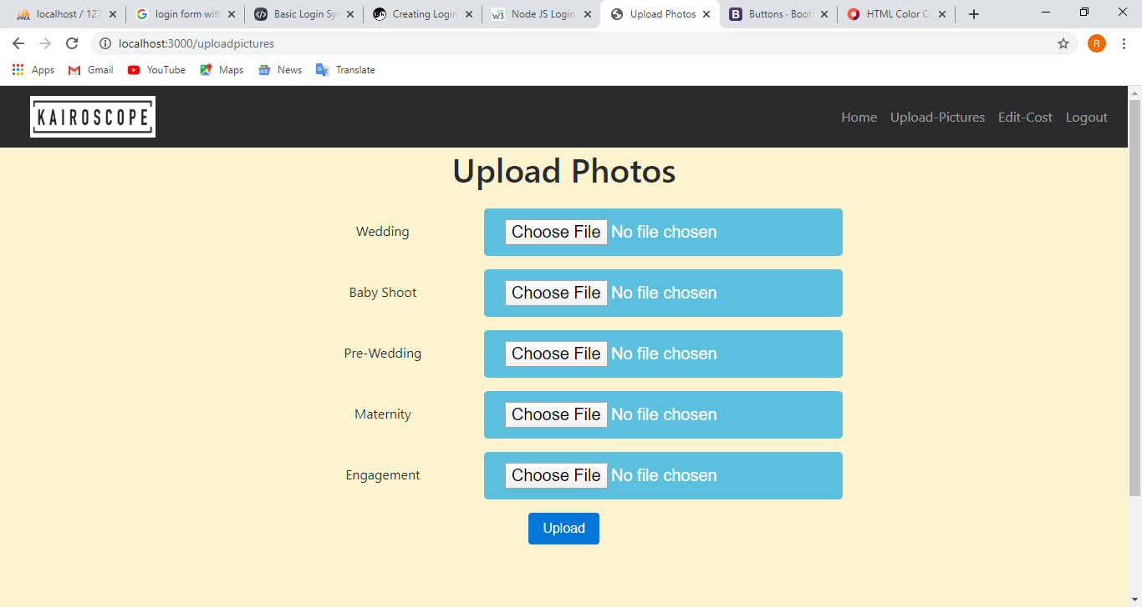

Edit Cost

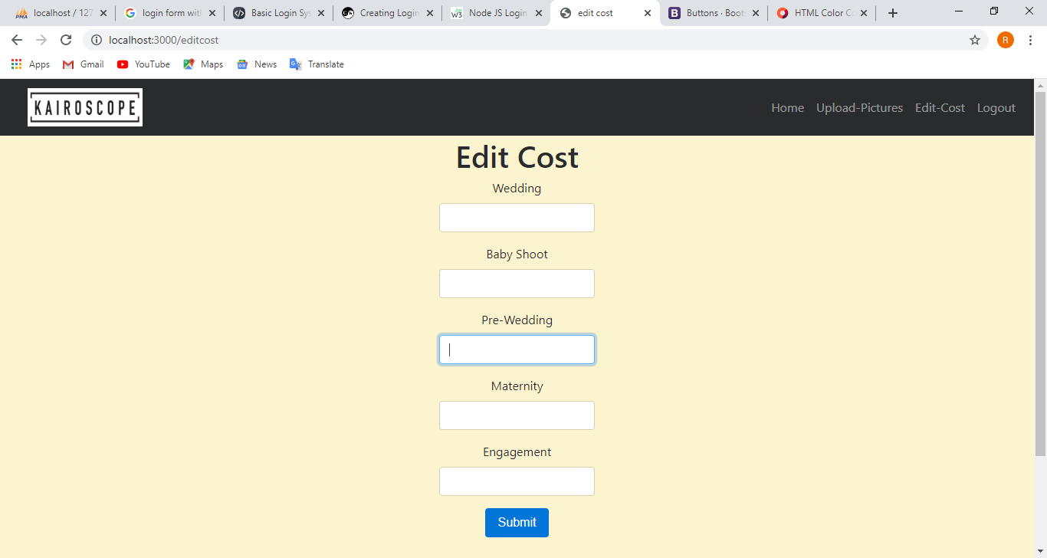

Add Personal Details

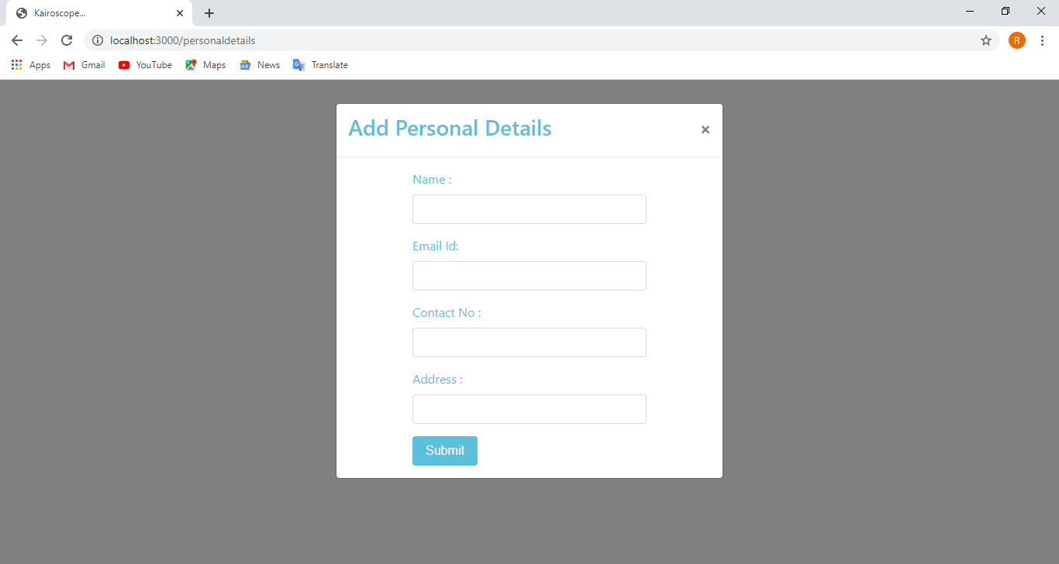

Add Event Details

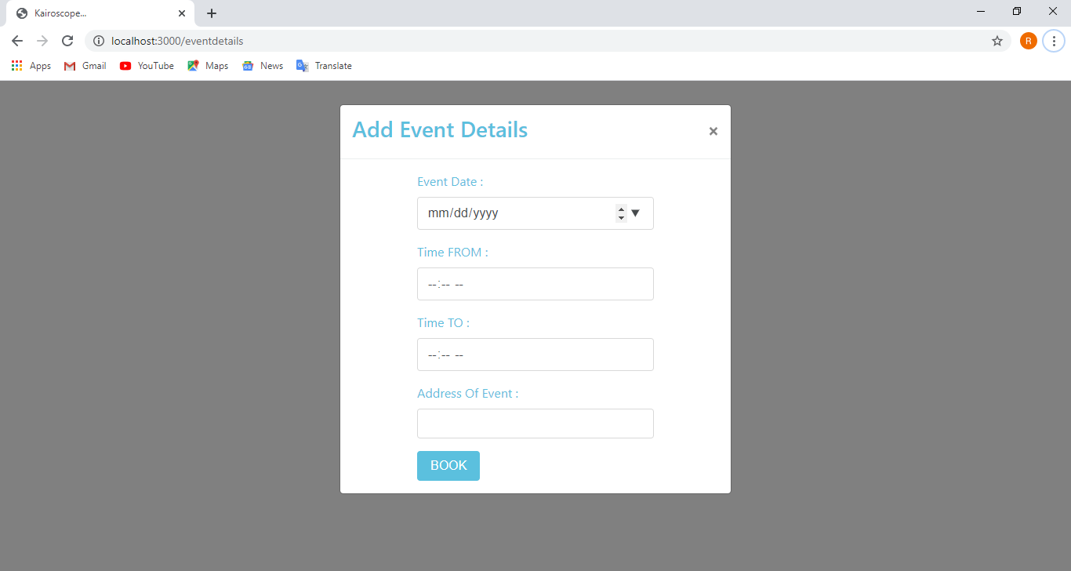

Book Photographer



Validation Screenshots

Admin Login

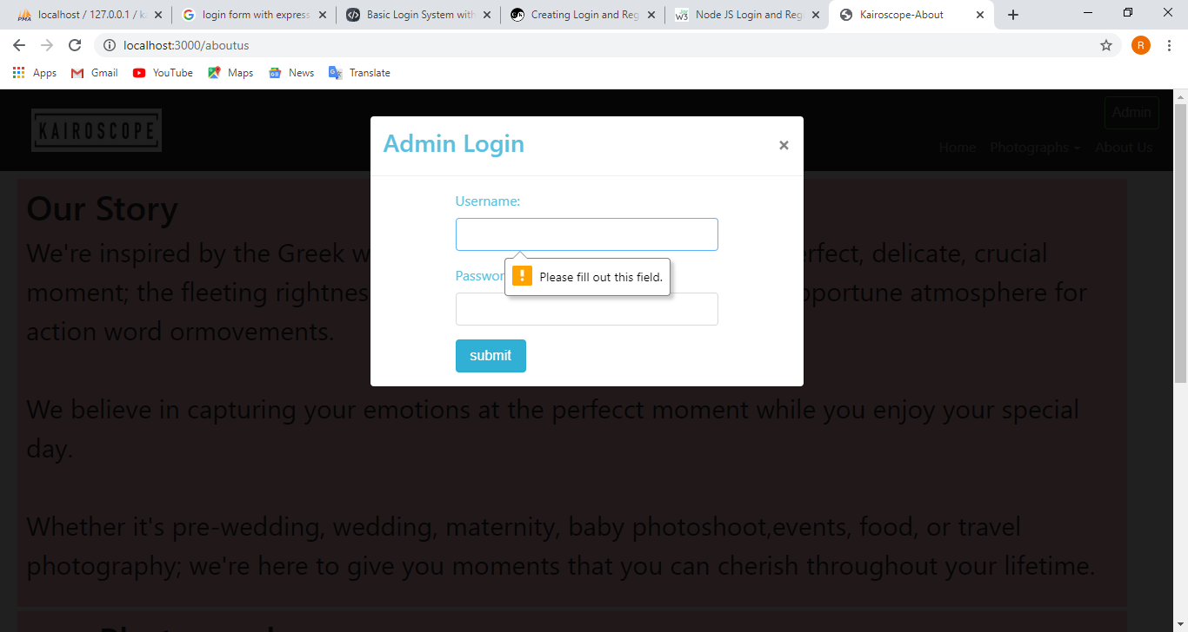

Add Personal Details

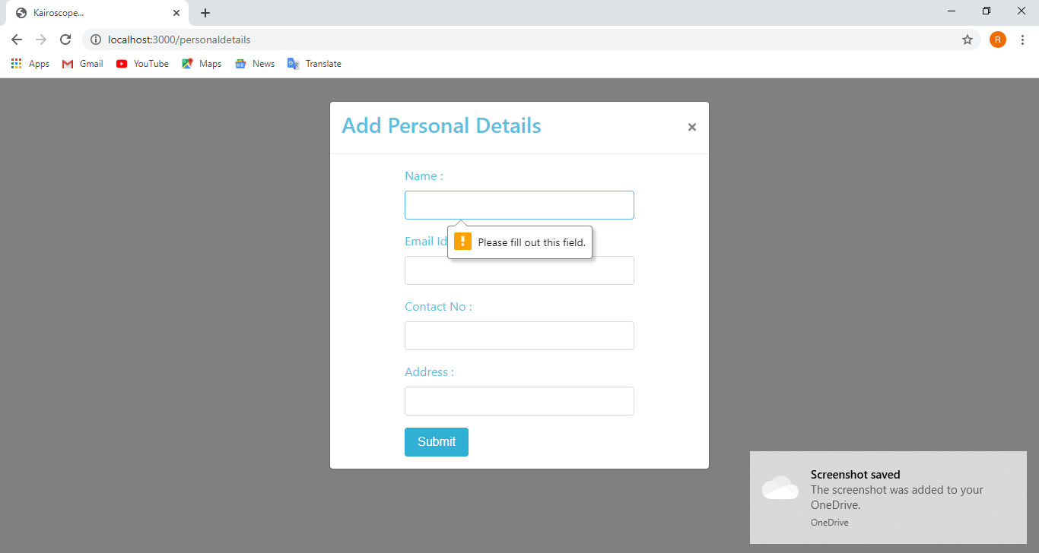

Add Events Details

